Supplementary Table 1. Search strategy for record extraction
Database | Search strategy
MEDLINE-Embase* | smoking:ab,ti OR smoke:ab,ti OR cigarette:ab,ti  AND  seizure:ab,ti OR seizures:ab,ti OR epilepsy:ab,ti OR convulsion:ab,ti  AND  maternal:ab,ti OR pregnancy:ab,ti OR prenatal:ab,ti OR antenatal:ab,ti OR perinatal:ab,ti  AND  ('article'/it OR 'article in press'/it) AND [humans]/lim
Web of Science | TI=(smoke) OR AB=(smoke) OR TI=(smoking) OR AB=(smoking) OR TI=(cigarette) OR AB=(cigarette)  AND  (TI=(seizure) OR AB=(seizure) OR TI=(seizures) OR AB=(seizures) OR TI=(epilepsy) OR AB=(epilepsy) OR TI=(convulsion) OR AB=(convulsion))  AND  (TI=(maternal) OR AB=(maternal) OR TI=(pregnancy) OR AB=(pregnancy) OR TI=(prenatal) OR AB=(prenatal) OR TI=(antenatal) OR AB=(antenatal) OR TI=(perinatal) OR AB=(perinatal))
Scopus | TITLE-ABS-KEY(smoke) OR TITLE-ABS-KEY(smoking) OR TITLE-ABS-KEY(cigarette)  AND TITLE-ABS-KEY(seizure) OR TITLE-ABS-KEY(seizures) OR TITLE-ABS-KEY(epilepsy) OR TITLE-ABS-KEY(convulsion)  AND TITLE-ABS-KEY(maternal) OR TITLE-ABS-KEY(pregnancy) OR TITLE-ABS-KEY(prenatal) OR TITLE-ABS-KEY(antenatal) OR TITLE-ABS-KEY(perinatal)
ScienceDirect | (smoke OR smoking OR cigarette)  AND  (Seizure OR epilepsy)  AND  (maternal OR pregnancy OR prenatal)
* The Embase database was utilized for the search as it encompasses the search conducted in MEDLINE.
Supplementary Table 2. Reasons for exclusion
Title | Reasons for exclusion
Short-term neonatal outcomes of pregnancies complicated by maternal obesity | Outcome of interest not reported
Financial incentives for smoking cessation in pregnancy: Multicentre randomised controlled trial | Study design not matched (RCT)
Prenatal tobacco smoke exposure and neurological impairment at 10-years of age among children born extremely preterm: a prospective cohort | Exposure of interest not reported (No available information)
Term Birth Weight and Neurodevelopmental Outcomes | Outcome of interest not reported
Prenatal, perinatal, and postnatal factors associated with autism spectrum disorder cases in Xuzhou, China | Outcome of interest not reported
Maternal cigarette use during pregnancy and school readiness: An analysis of preschool age children in Sao Paulo, Brazil | Outcome of interest not reported
Pregnancy outcome in women with cerebral palsy: A nationwide population-based cohort study | Study population not relevant (mothers with cerebral palsy)
Risk of febrile seizures among children conceived following fertility treatment: A cohort study | Exposure of interest not reported (fertility treatment, no smoking data)
Maternal complications in pregnancy and childbirth for women with epilepsy: Time trends in a nationwide cohort | Outcome of interest not reported
Fertility and birth outcomes in women with epilepsy seeking pregnancy | Outcome of interest not reported
Relation of in-utero exposure to antiepileptic drugs to pregnancy duration and size at birth | Exposure of interest not reported
Fertility and birth outcomes in women with epilepsy seeking pregnancy | Exposure of interest not reported
Prenatal exposure to antipsychotic medication and use of primary health care system in childhood: A population-based cohort study in Denmark | Exposure of interest not reported (marijuana, not smoking)
Maternal marijuana use, adverse pregnancy outcomes, and neonatal morbidity | Outcome of interest not reported
Characteristics of Spontaneous Births Attended by Midwives and Physicians in US Hospitals in 2014 | Exposure of interest not reported (antibiotics, not smoking)
The clinical significance of an estimated fetal weight below the 10th percentile: a comparison of outcomes of <5th vs 5th??th percentile | Outcome of interest not reported
Association between pregnancy and perinatal outcomes among Women with epilepsy | Outcome of interest not reported
Epilepsy, birth weight and academic school readiness in Canadian children: Data from the national longitudinal study of children and youth | Outcome of interest not reported
Inter-pregnancy Weight Change and Risks of Severe Birth-Asphyxia-Related Outcomes in Singleton Infants Born at Term: A Nationwide Swedish Cohort Study | Exposure of interest not reported
Association between Antibiotic prescribing in pregnancy and cerebral palsy or epilepsy in children born at term: A cohort study using the Health Improvement Network | Exposure of interest not reported
Apgar-score in children prenatally exposed to antiepileptic drugs: A population-based cohort study | Exposure of interest not reported
Maternal Overweight and Obesity and Risks of Severe Birth-Asphyxia-Related Complications in Term Infants: A Population-Based Cohort Study in Sweden | Exposure of interest not reported (antidepressants, not smoking)
Early child development and exposure to antiepileptic drugs prenatally and through breastfeeding: A prospective cohort study on children of women with epilepsy | Outcome of interest not reported
Delivery outcome in relation to maternal use of some recently introduced antidepressants | Outcome of interest not reported
Morbidity of Danish infants during their first months of life. Incidence and risk factors | Outcome of interest not reported
Low 5-minute Apgar score: A population-based register study of 1 million term births | Outcome of interest not reported
Cohort Profile: The Copenhagen Baby Heart Study (CBHS) | Exposure of interest not reported (breastfeeding, not smoking)
Associations between Pregnancy-Related Predisposing Factors for Offspring Neurodevelopmental Conditions and Parental Genetic Liability to Attention-Deficit/Hyperactivity Disorder, Autism, and Schizophrenia: The Norwegian Mother, Father and Child Cohort Study (MoBa) | Exposure of interest not reported
Breastfeeding and risk of febrile seizures in infants: The Japan Environment and Children's Study | Exposure of interest not reported
Perinatal Outcomes and Factors Associated with Ethnic Group in cases of Preterm Birth: The Multicenter Study on Preterm Birth in Brazil | Study population not relevant (migrant comparison study, no smoking or seizure data)
Neonatal Seizures Among Low-Risk Pregnancies at Term Risk Factors and Adverse Outcomes | Outcome of interest not reported
The Perinatal Outcomes of Maltese and Sub-Saharan African Migrant Women: A Comparative, Retrospective Study | Study design not matched (RCT)

Supplementary Table 3. Risk of bias assessment included studies – Newcastle-Ottawa Scale
Case-control studies* | Selection |  |  |  | Comparability | Exposure |  |  | Assessment***
 | Is the case definition adequate? | Representativeness of cases | Selection of Controls | Definition of Controls | Comparability based on design and analysis | Assessment of exposure | Same method of ascertainment for cases and controls | Non-response rate
Cassano, 1990 | 1 |  |  | 1 | 1 | 1 | 1 | 1 | Fair
Berg, 1995 | 1 | 1 | 1 | 1 | 1 | 1 | 1 | 1 | Good
Heydarian, 2018 | 1 | 1 |  | 1 | 1 |  | 1 |  | Poor
Habbal, 2021 | 1 | 1 |  | 1 | 1 | 1 | 1 | 1 | Good
Sidenvall, 2001 | 1 | 1 |  | 1 | 1 |  | 1 | 1 | Good
McLaren, 2022 | 1 | 1 |  |  |  |  | 1 |  | Poor
Cohort studies** | Representativeness of the sample | Selection of the non-intervention cohort | Ascertainment of exposure | Demonstration that outcome of interest was not present at start of study | Comparability based on design and analysis | Assessment of outcome | Was follow up long enough for outcomes to occur | Adequacy of follow- up of cohorts | Assessment*
Nelson, 1990 | 1 | 1 | 1 | 1 |  | 1 |  |  | Poor
Greenwood, 1998 | 1 | 1 | 1 | 1 |  | 1 | 1 | 1 | Poor
Vahidnia, 2008 | 1 | 1 | 1 | 1 |  | 1 | 1 |  | Poor
Mitsuda, 2019 | 1 | 1 | 1 | 1 |  | 1 | 1 |  | Poor
Nunes, 2011 | 1 | 1 | 1 | 1 |  | 1 | 1 |  | Poor
Rantakallio, 1987 | 1 | 1 | 1 | 1 | 1 |  | 1 | 1 | Good
Specht, 2020 | 1 | 1 |  |  |  | 1 | 1 |  | Poor
Doty, 2020 | 1 | 1 | 1 | 1 |  | 1 | 1 |  | Poor
* Is the case definition adequate?: Independent validation of cases / Representativeness of cases: Consecutive or obviously representative series of cases / Selection of Controls: Community-based controls / Definition of Controls: Controls with no history of the disease of interest / Comparability based on design and analysis: Studies controlling for the most important factor and any additional confounders / Assessment of exposure: Secure records (e.g., surgical records) or structured interviews blinded to case/control status / Same method of ascertainment for cases and controls: Identical exposure assessment methods for cases and controls / Non-response rate: Similar response rates between cases and controls
**Representativeness of the sample: Truly or somewhat representative of the average population in the community / Selection of the non-intervention cohort: Drawn from the same community as the exposed cohort / Ascertainment of exposure: Secure records or structured interviews / Demonstration that outcome of interest was not present at start of study: Outcome of interest confirmed absent at study initiation / Comparability based on design and analysis: Studies controlling for the most important factor and any additional confounders / Assessment of outcome: Independent blind assessment or record linkage / Was follow-up long enough for outcomes to occur: Sufficient duration for the outcome to occur / Adequacy of follow-up of cohorts: Complete follow-up or minimal loss (<10%), with description of losses where applicable
*** Good quality: 3 or 4 points in selection domain AND 1 or 2 points in compatibility domain AND 2 or 3 points in outcome/exposure domain, Fair quality: 2 points in selection domain AND 1 or 2 points in comparability domain AND 2 or 3 points in outcome/exposure domain, Poor quality: 0 or 1 point in selection domain OR 0 points in comparability domain OR 0 or 1 point in outcome/exposure domain

Supplementary Figure 1. Forest plot illustrating the association between maternal smoking during pregnancy and the risk of febrile convulsions in offspring

Supplementary Figure 2. Forest plot illustrating the association between maternal smoking during pregnancy and the risk of epilepsy and afebrile seizures in offspring

Supplementary Figure 3. Forest plot illustrating the association between maternal smoking during pregnancy and the risk of neonatal seizures in offspring

Supplementary Figure 4. Forest plot illustrating the association between maternal smoking during pregnancy and the risk of seizures in offspring in case-control studies

Supplementary Figure 5. Forest plot illustrating the association between maternal smoking during pregnancy and the risk of seizures in offspring in cohort studies

Supplementary Figure 6. Leave-one-out sensitivity analysis assessing the robustness of the association between maternal smoking during pregnancy and the risk of seizures in offspring
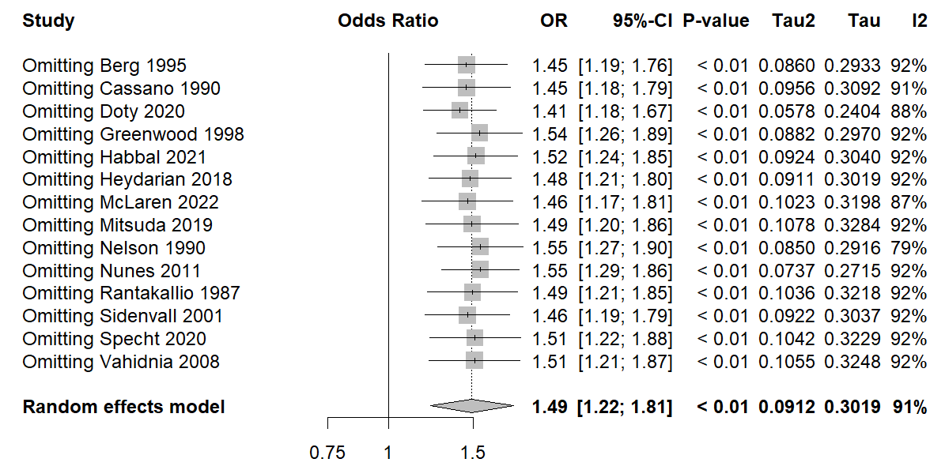

Supplementary Figure 7. Forest plot showing the association between maternal smoking during pregnancy and the risk of seizures in offspring, based on sensitivity analysis excluding studies rated as ‘poor’ in quality
